**Environment:** Analysis was performed on TEST environment.

General info:

|  |  |  |  |  |  |
| --- | --- | --- | --- | --- | --- |
|  | **Host** | **Type** | **IP** | **Hosted Applications** | **Ports** |
| STAGING | EPUAKYIW1686T1 | VM | 10.17.175.63 | EPUAKYIW1686T1.kyiv.epam.com | 8080, 4444 |

System resources (TEST env):

|  |  |  |
| --- | --- | --- |
| **CPU, GHz** | **Memory, Gb** | **Disk size, Gb** |
| 2 | 8.192 | 100 |

**Test scenario**

There is a combined scenario which is to include the scripts:

• Task 4 (admin)

• Task 5 (editor)

• Task 6 (anonymous)

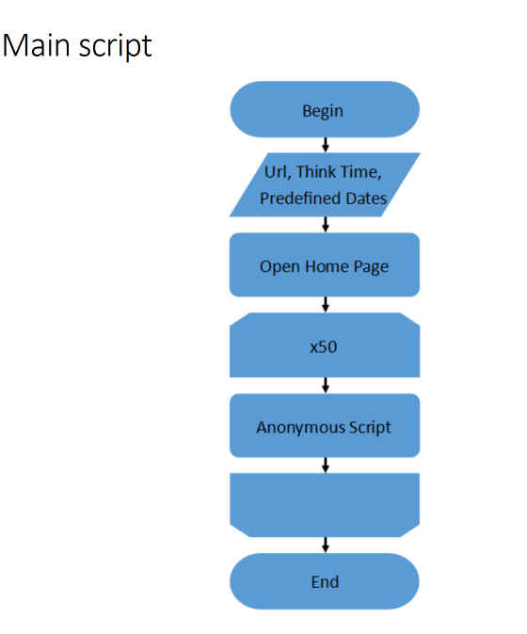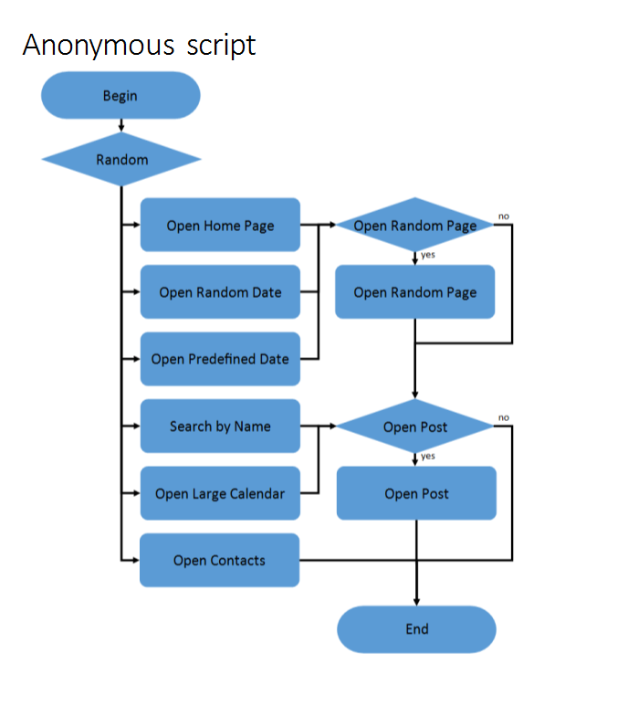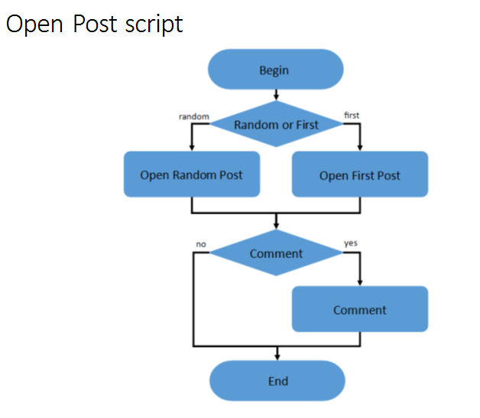

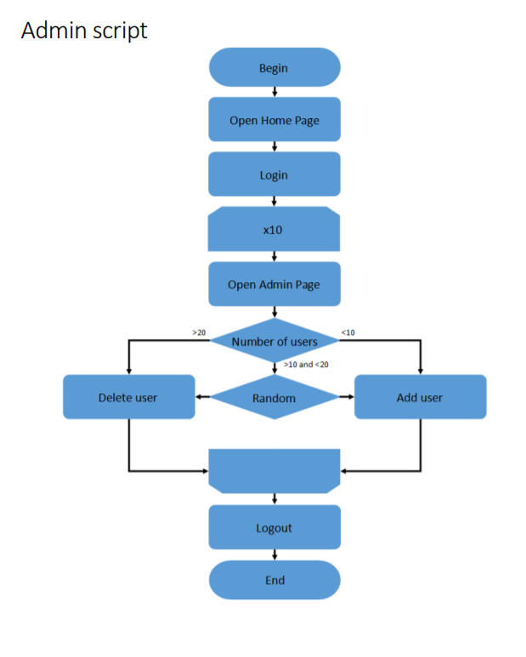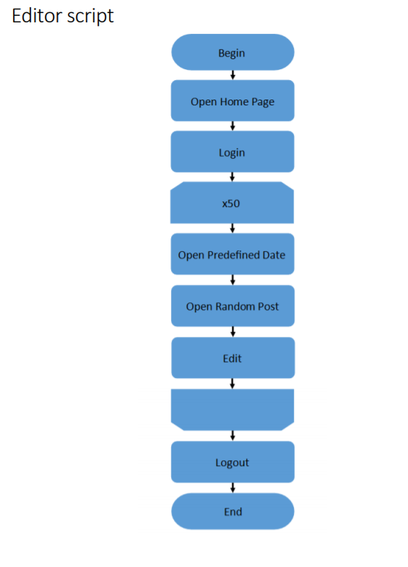

**Test conditions**

|  |  |
| --- | --- |
| **Transaction** | **Condition for anonymous script** |
| open home page | 15% |
| open random date | 10% |
| open predefined date | 30% |
| search by name | 30% |
| open large calendar | 10% |
| open contacts | 5% |
| open random page | 50% |
| open post | 80% |
| open random post | 65% |
| open first post | 35% |
| add comment | 20% |

**Test Setup**

|  |  |
| --- | --- |
|  | Condition |
| number of virtual users | Up to 40 – Anonymous  2 – Admins  2 – Editors |
| ramp-up period(sec) | 400 – Anonymous  30 – Admin  30 ­­­– Editor |
| duration(sec) | 600 |
| think time (sec) | 3-5 |

**Data Setup**

|  |  |  |
| --- | --- | --- |
| Configuration | Posts amount | Posts data |
| **1** | 100 | Text only |
| **2** | 1000 |
| **3** | 2000 |
| **4** | 5000 |

**Test Results**

|  |  |  |  |  |
| --- | --- | --- | --- | --- |
| Configuration | Avg throughput, ops | Avg response time,  ms | Avg CPU % | Avg Processor time % for ISS |
| **1** | 6.99 | 49 | 29 | 16 |
| **2** | 6.96 | 71 | 43 | 27 |
| **3** | 6.85 | 107 | 35 | 39 |
| **4** | 6.68 | 462 | 51 | 79 |

**Test Summary**

1 From gathered results, we can see that slight degradation starts from 2000 posts and huge degradation from 5000.

Firstly, throughput 6.99ops(100 posts), 6.96ops(1000 posts) against 6.85ops(2000 posts) and 6.68ops(5000posts).

Secondly, avg response time 49ms(100 posts), 71ms(1000 posts) against 107ms(2000 posts) and 462ms(5000posts).

2 Degradation could be found on each request see Metrics Overview. Main requests with huge degradations Change Post transaction, Comment transaction, Open First Post transaction, Open Random Post transaction.

3 There is degradation on server mostly in Processor time % for ISS and Queue Size for HTTP Service Request Queues, request queue present only for 4 Data configuration.

Processor time % (avg)

16% - (1 Data configuration)

27 % - (2 Data configuration)

39 % - (4 Data configuration)

79 % - (5 Data configuration)

**Recommendation**

1 Additional testing on 8000 and 10 000 to get info on how a system works on this configuration.

**Results: graphs and tables(for more details open dashboard HTMLReport > index)**

1. Metrics Overview

1 Data configuration

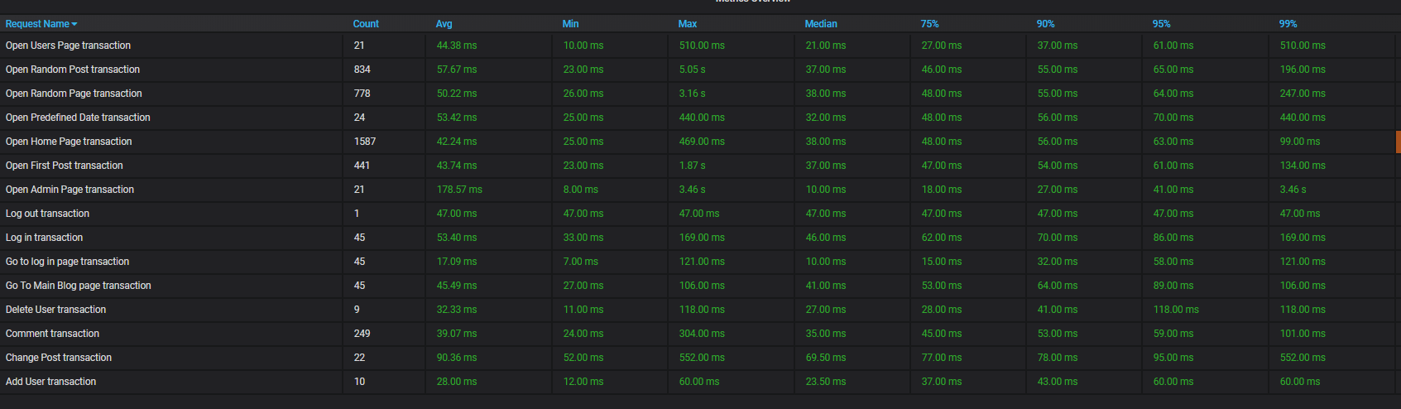

2 Data configuration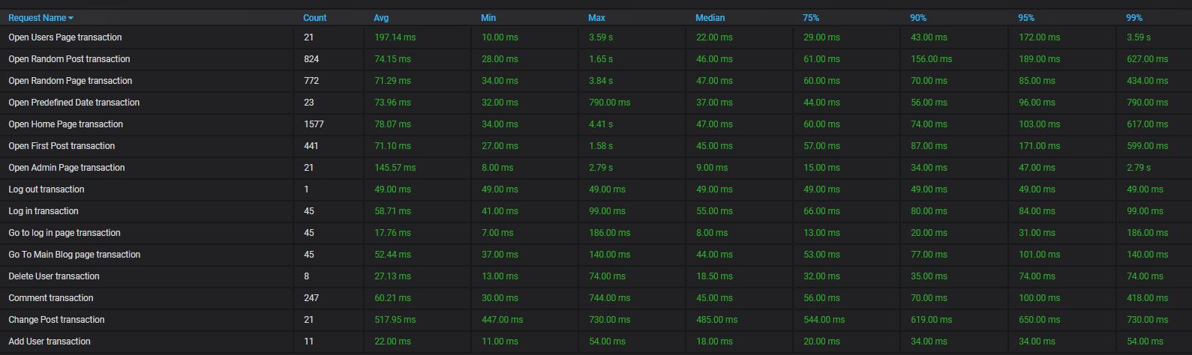

3 Data configuration

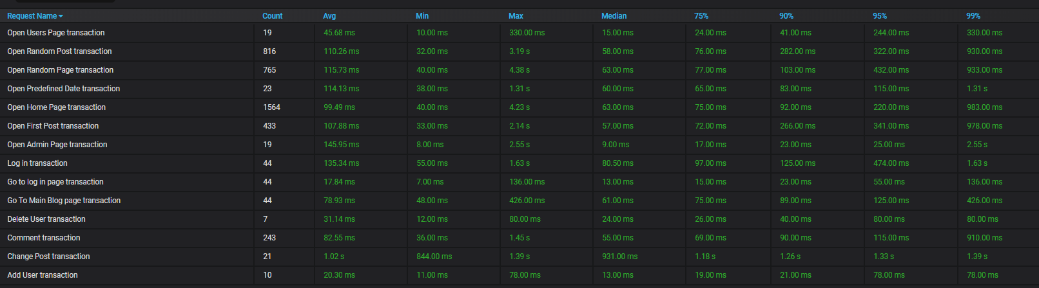

4 Data configuration

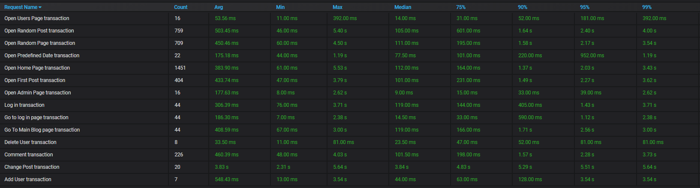

2 Processor time %

1 Data configuration

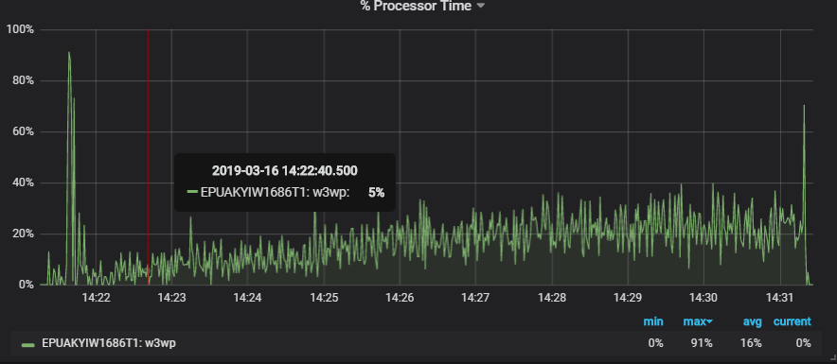

2 Data configuration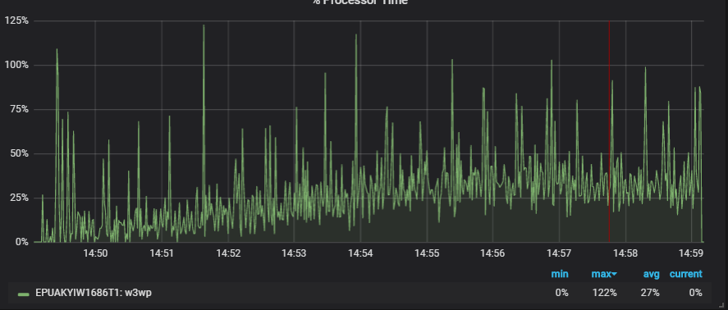

3 Data configuration

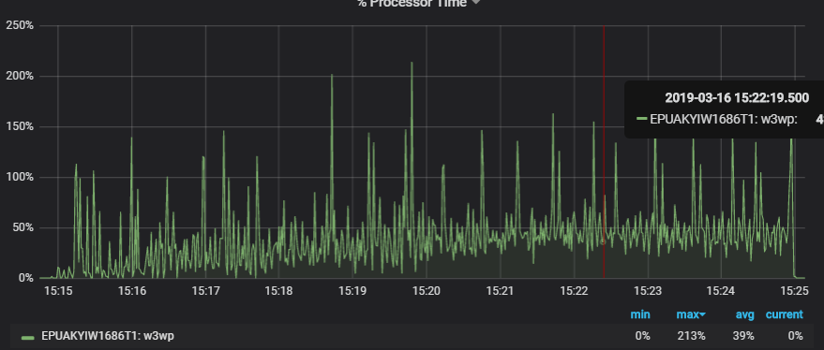

4 Data configuration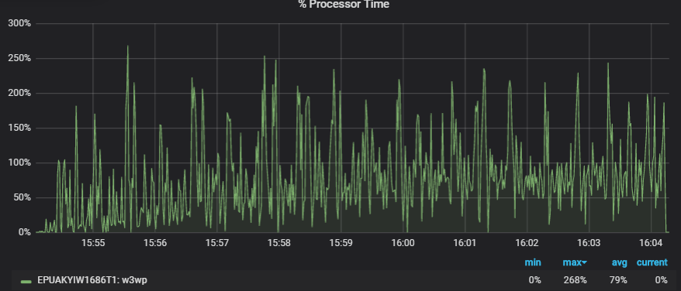

3 HTTP Service Request Queues

4 Data configuration

